1200sq/ft, 2 storey, 3 Bedroom Modern Home

By Weston Butcher

Marketing

* Target Audience

The intended target audience is potential clients looking at a proposed structure

* Platform

The platform is Windows OS utilizing the Unity game engine

* Competitors

Other Engineering or Architecture Firms who could have a different proposal

High Concept

The purpose of the project is to show the client a visual 3D representation of the building that they can walk around in to give insight on the interior and exterior and give feedback on any possible changes that they wish to ensure that the final virtual representation can be built without any major hiccups

Gameplay

* First Minutes

When spawning into the world the user will aware of the desired building in an artificial landscape. The game environment may not translate to the real world build site however having a background can complement the building. The user will also be exposed to exterior elements of the building

* Game Flow

When viewing the building from the inside or outside there will be assigned interactive objects that will provide information through a popup text box

* Players

The game is only single player

Art

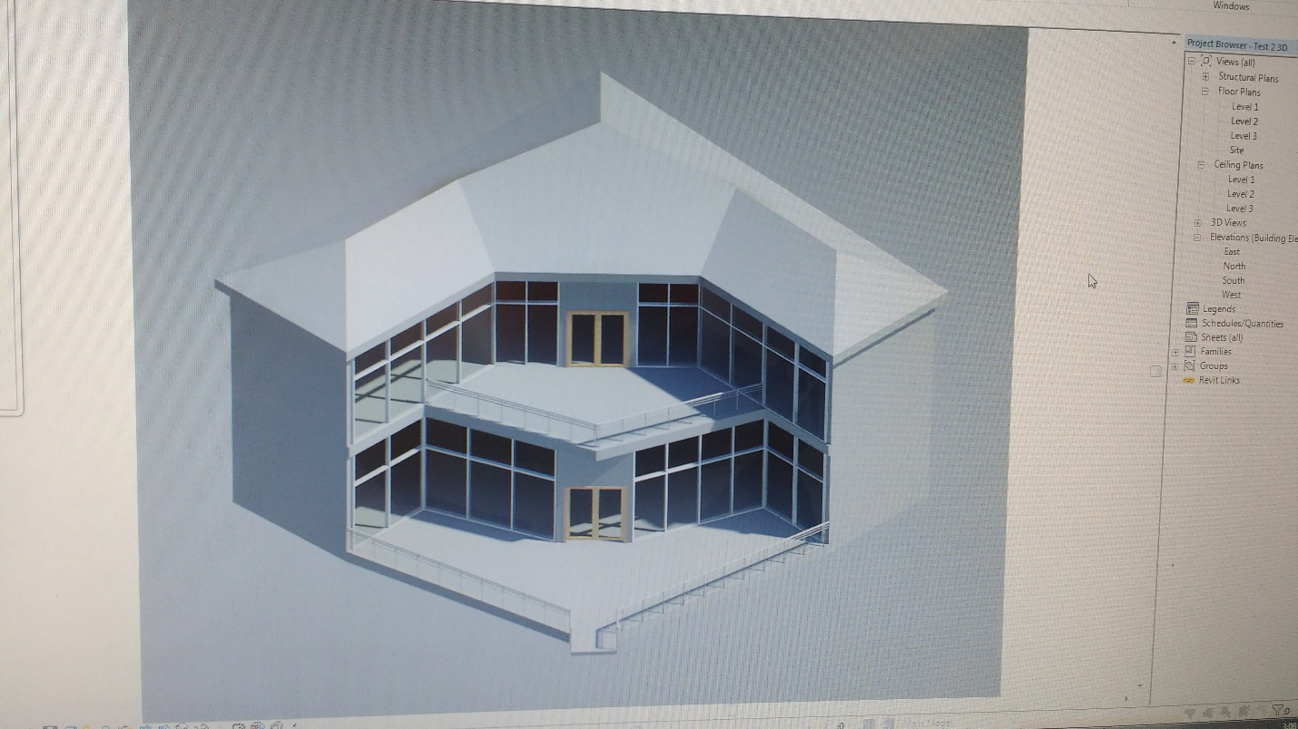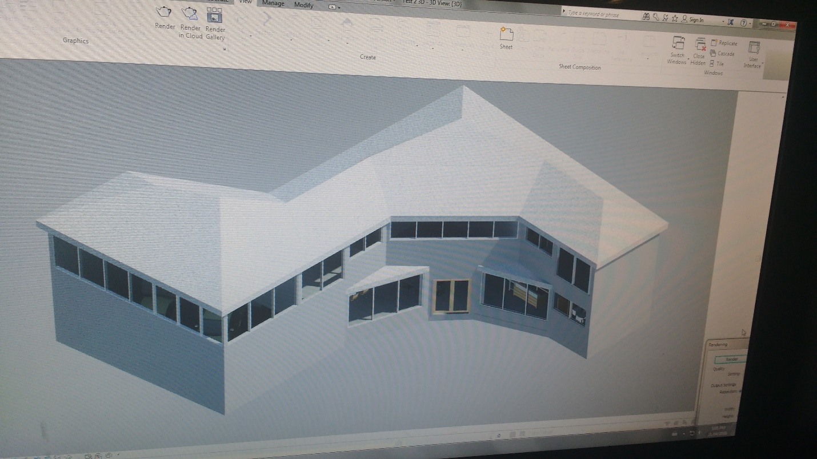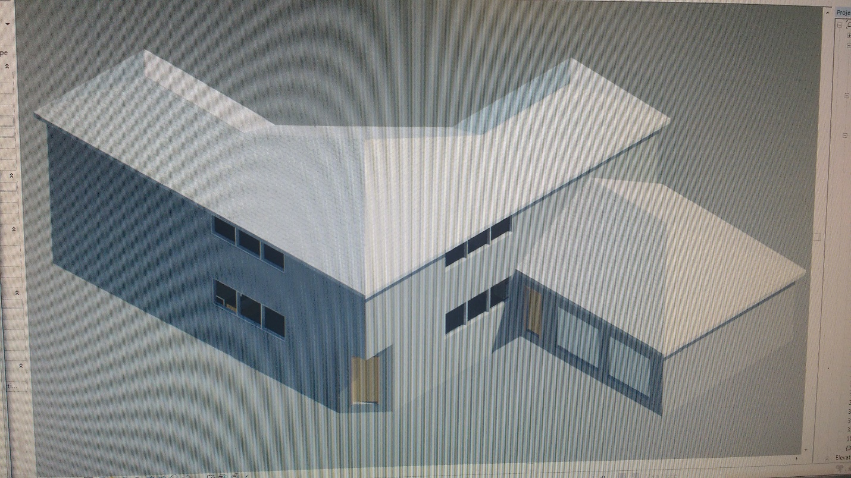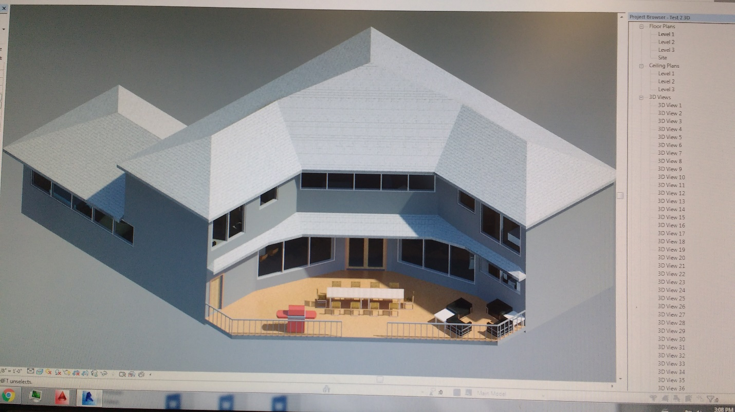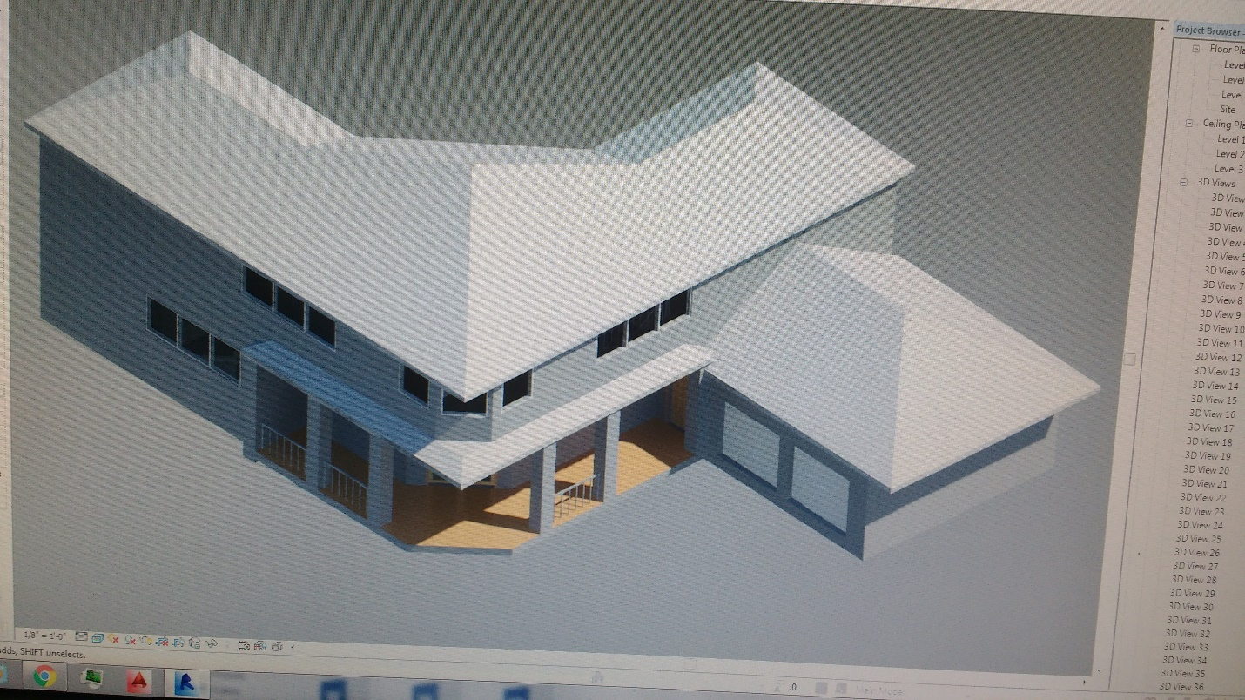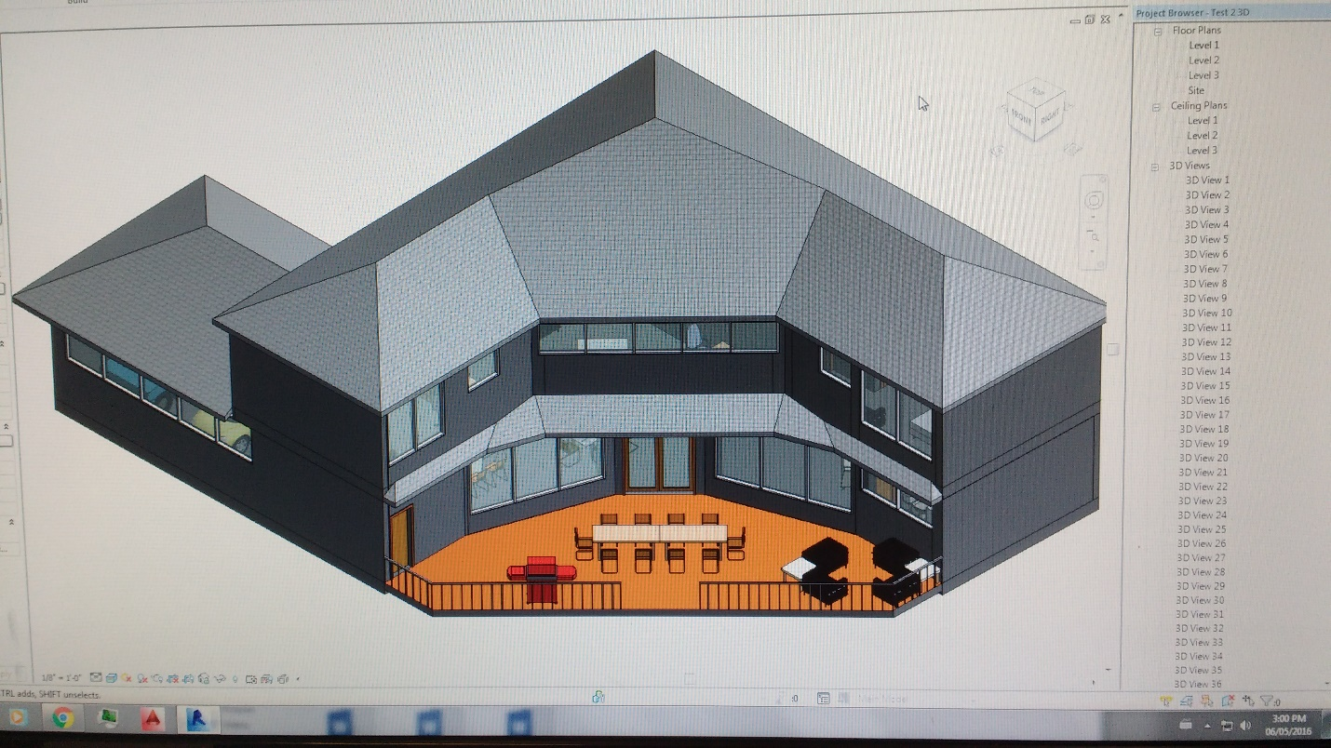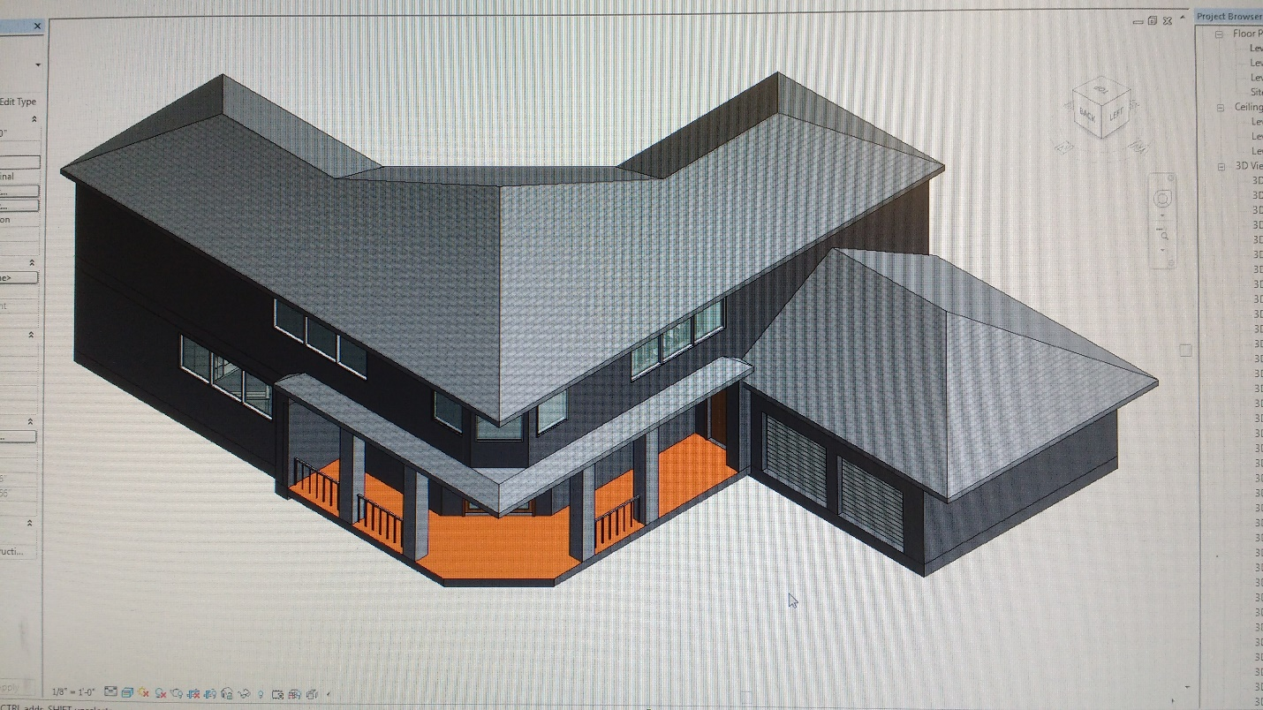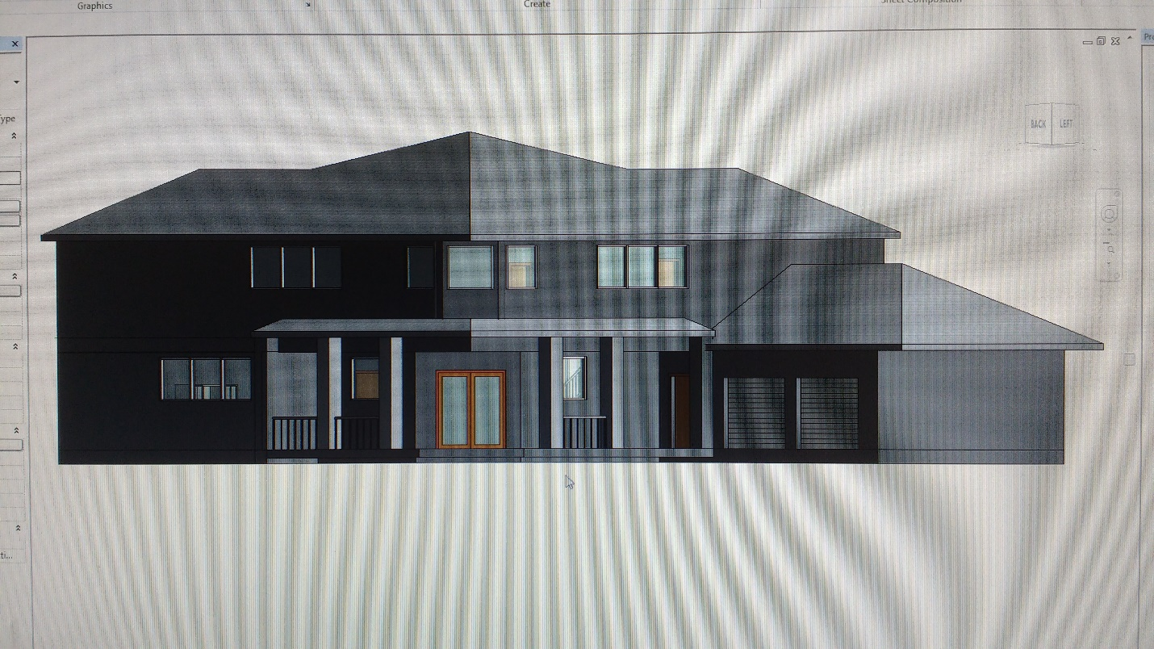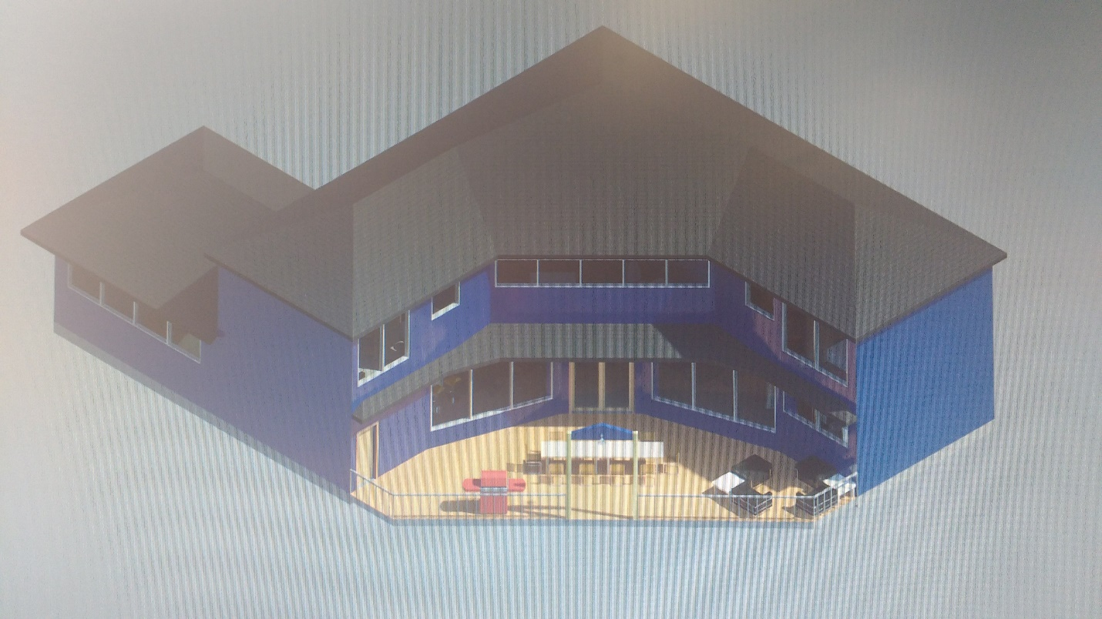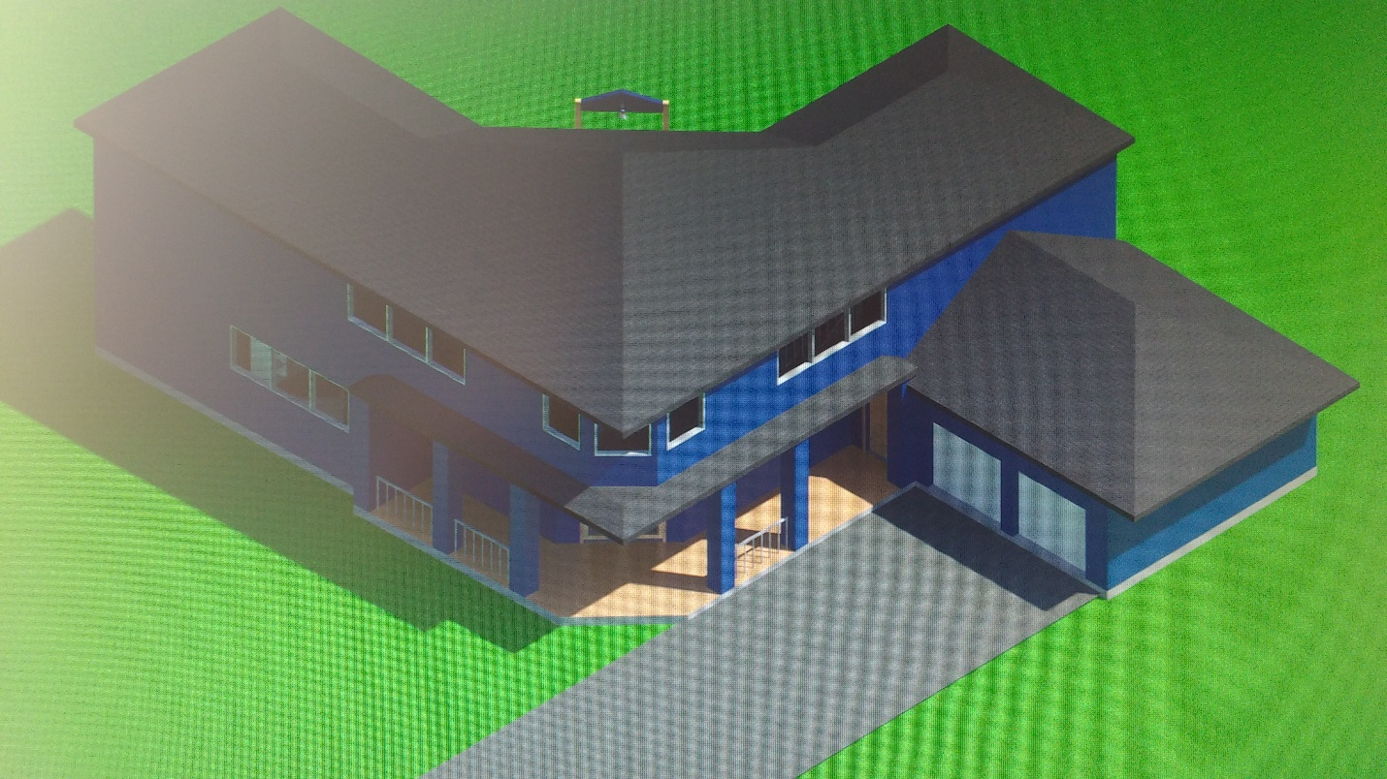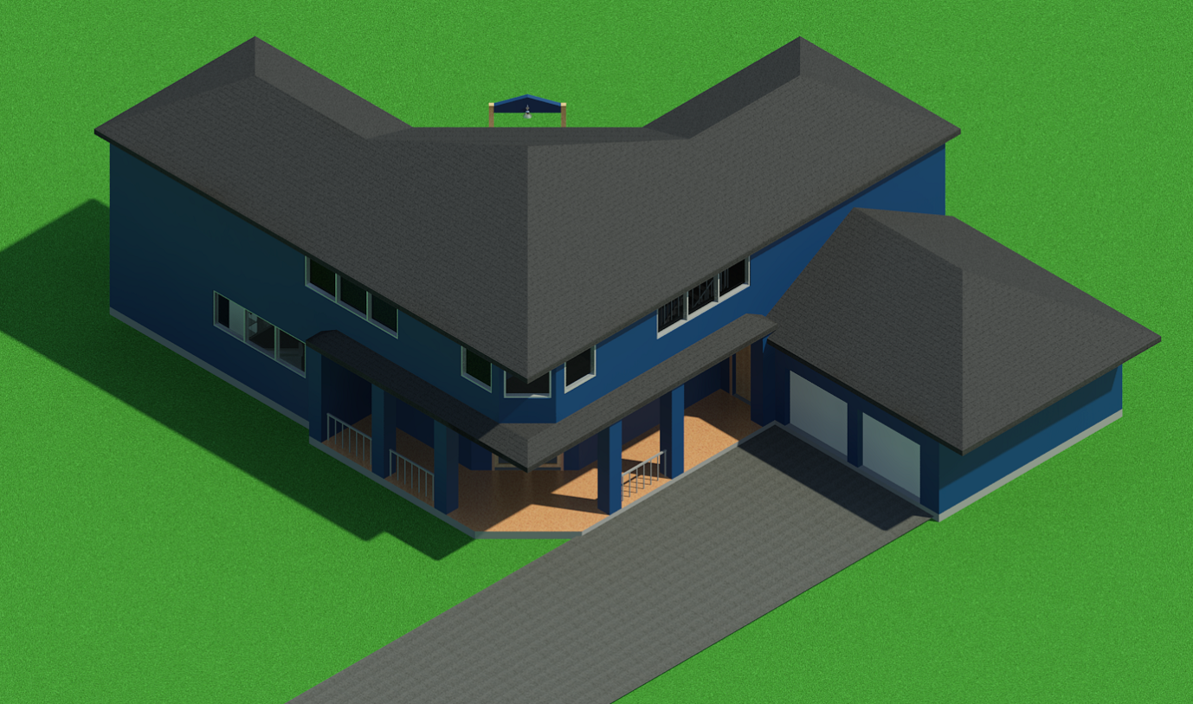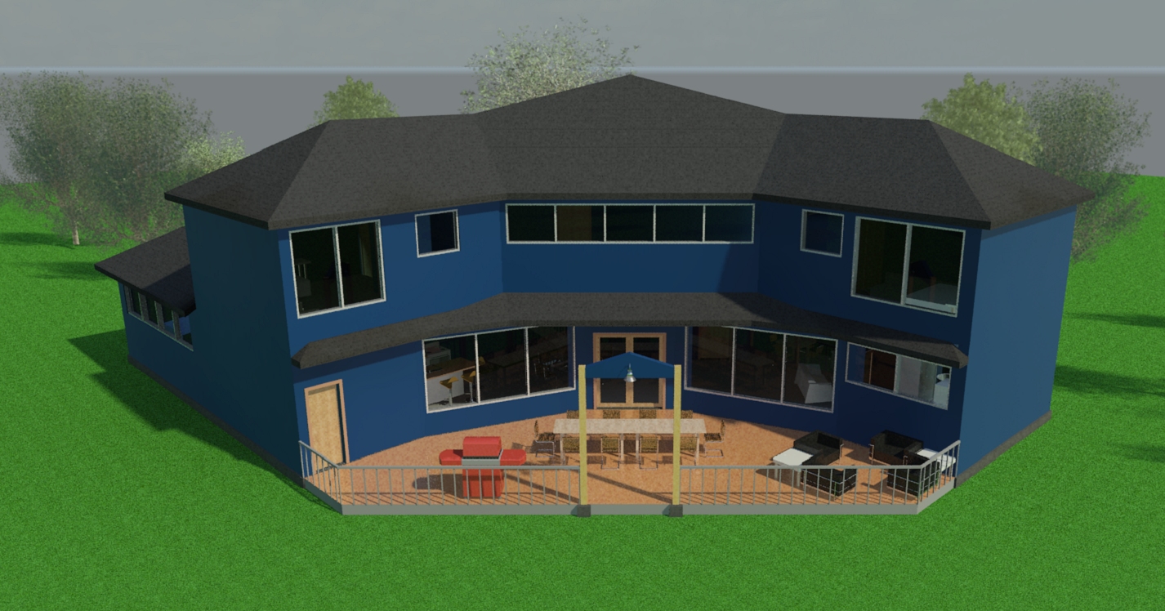

Technical Aspects

The models and most textures are imported from Revit and the required hardware to run Unity at a smooth rate heavily depends on how large/complex the Revit model is. In this specific case, most decent computers today are still capable of a decent frame rate.